Northcentral Technical College
Nelnet Past-due Payment Plan
Step-by-step Instructions

Use the following link to access the Nelnet login page
https://www.nbspayments.com/signin/4KCVP

If you have had a Nelnet payment plan in the past, you can use the same username and password login information. If you are a first-time user you will need to create an account by clicking on the Create a username & password link.
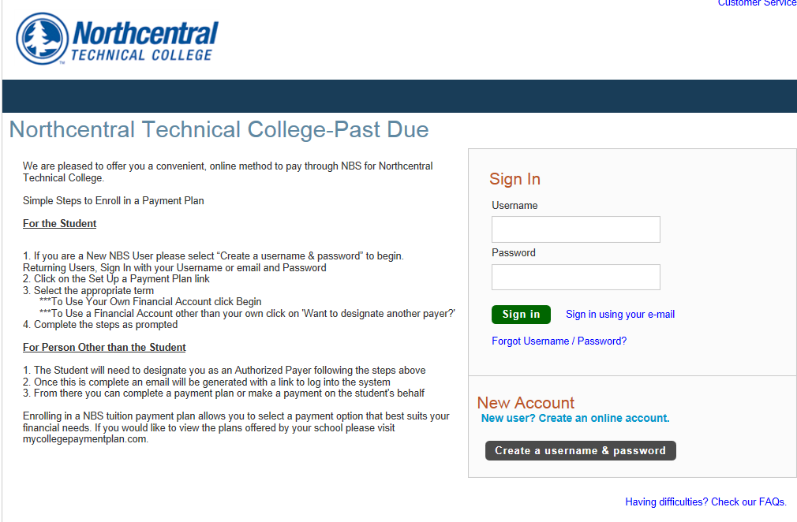
Once logged in, you should be at this screen.
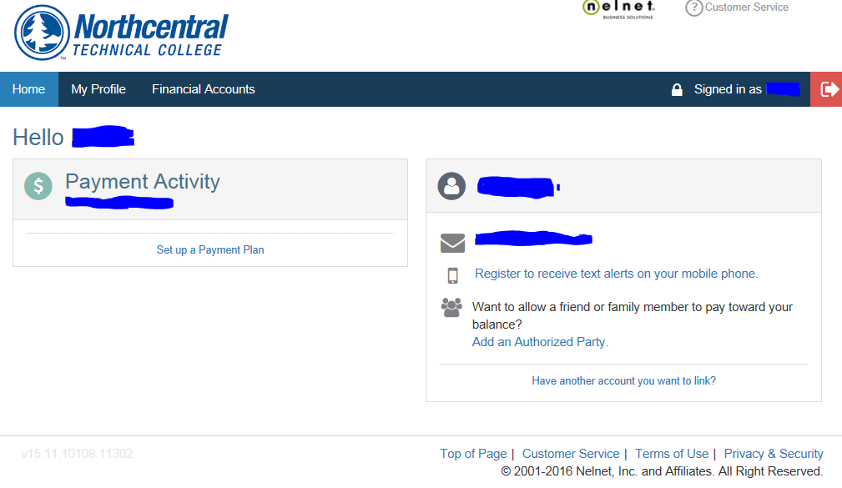
Click on Set up a Payment Plan
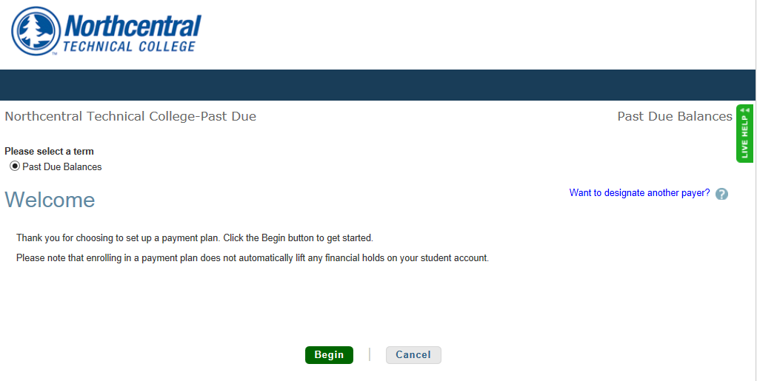
Click Begin
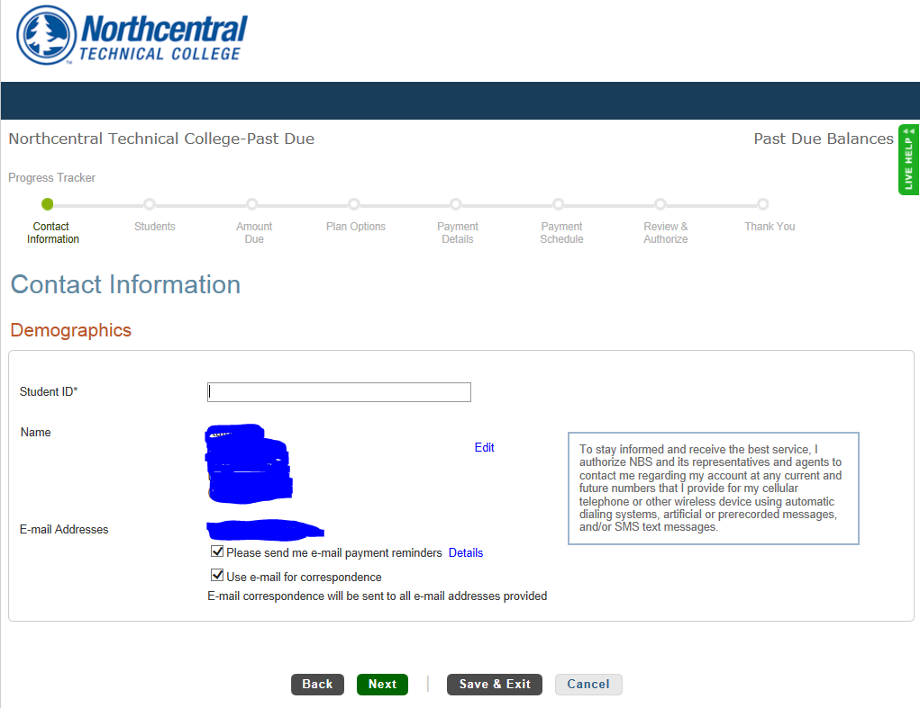
Enter your student ID and click Next

Click Add Student
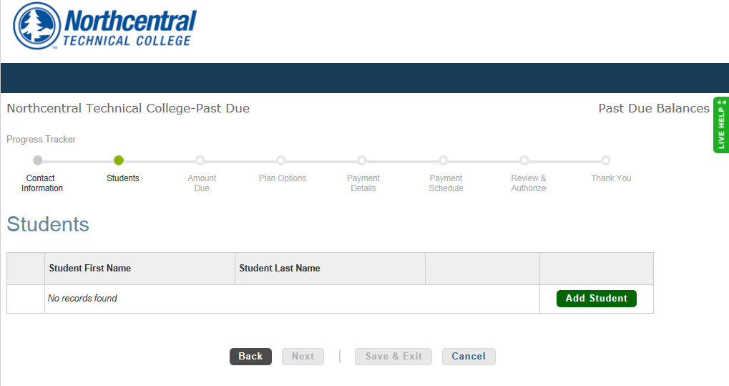
Enter your student ID, first name and last name as they appear in your myNTC. Click Save
If your name has changed, please contact NTC to have your records updated.
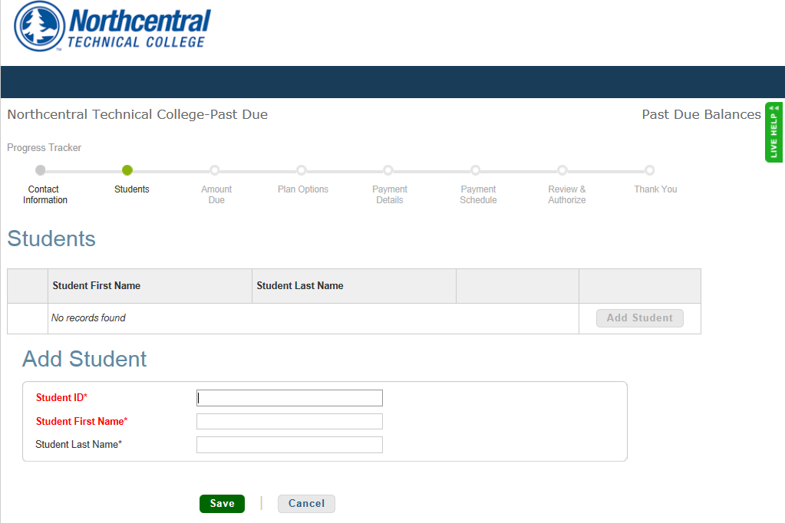

Click Add Student
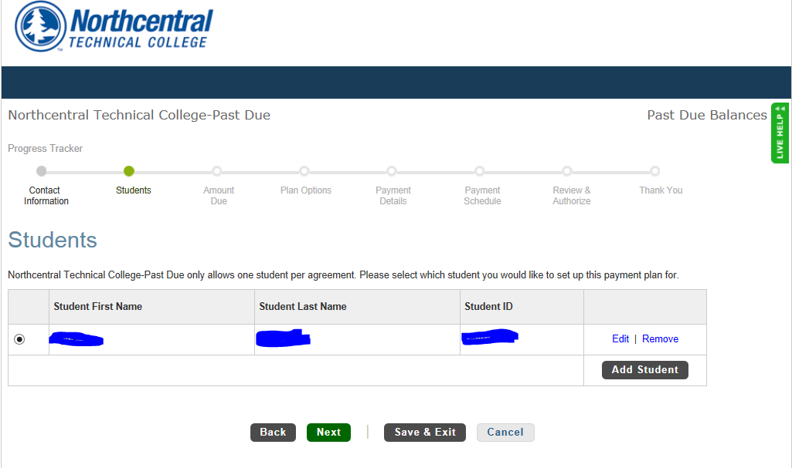
Click Next
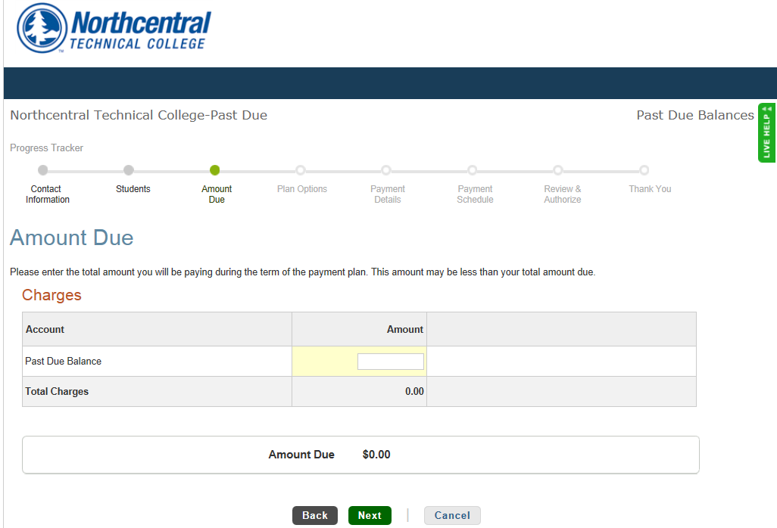Enter the amount you want financed under this plan. This may not be your total balance due. Please refer to your email. Click next.
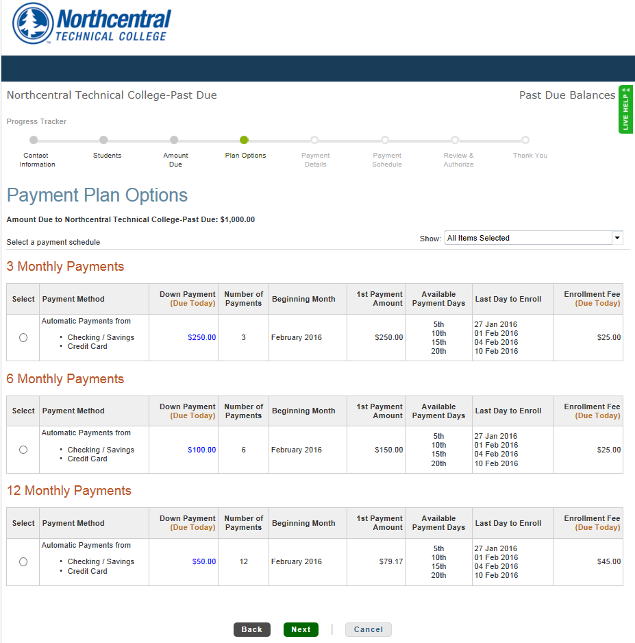
Choose either the 3, 6, or 12 month plan. Please refer to your email. Click Next
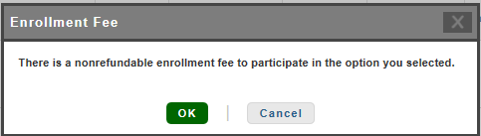
Click OK
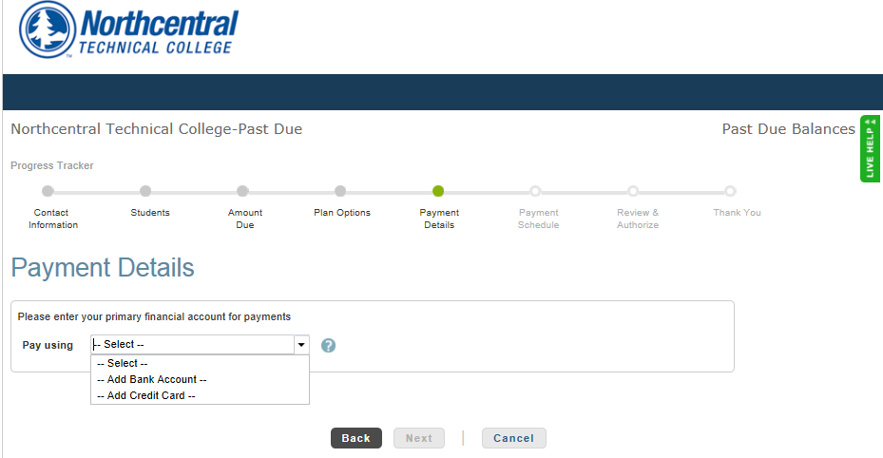
Click on the drop-down and choose Add Bank Account or Add Credit Card. Enter your payment details.
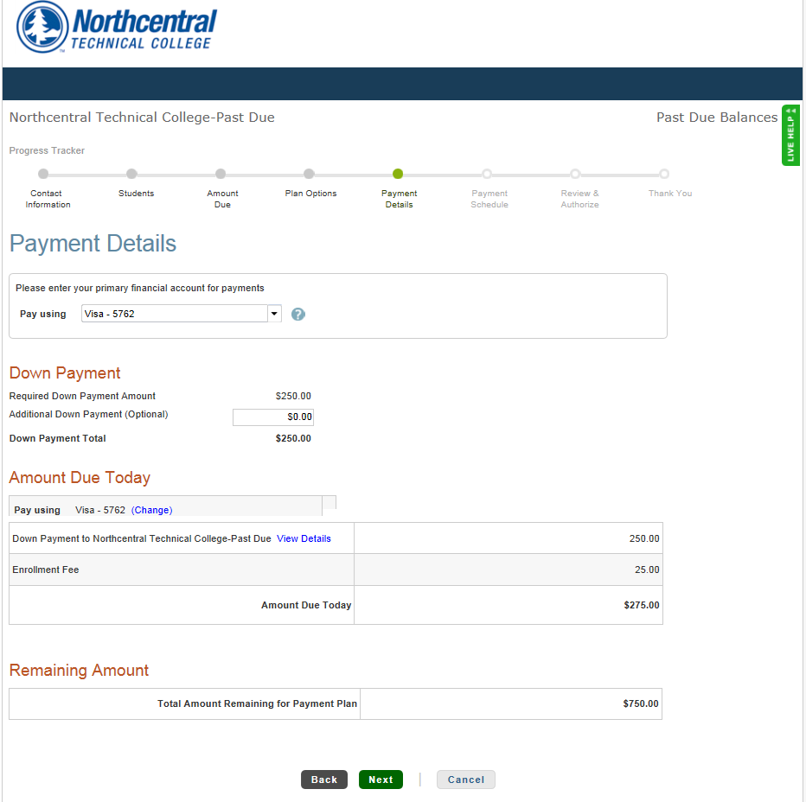
Click Next
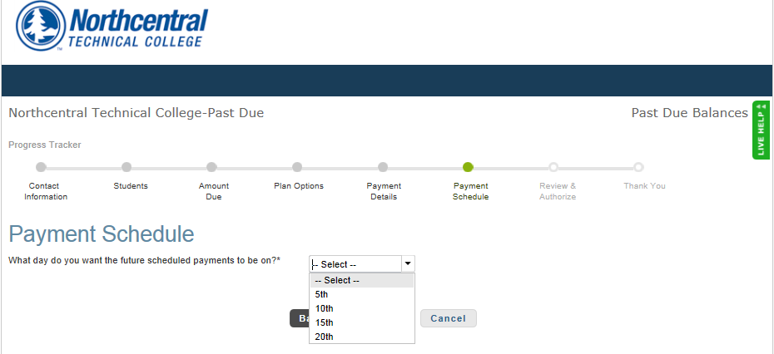
Click on the drop-down and choose the day of the month you want your payment processed.
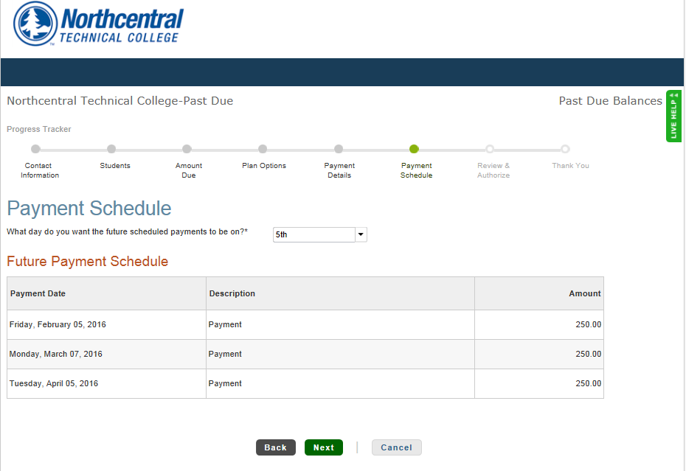
Click Next
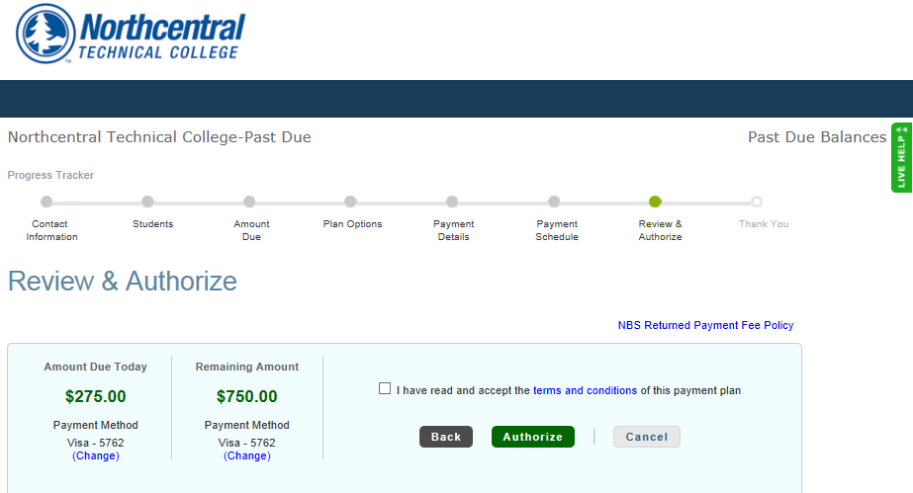
Scroll through this entire page to review your payment dates and amounts and the terms and conditions of the payment plan. Check the box indicating you have read and accept the terms and conditions and click Authorize.

